1. **Class diagrams:**

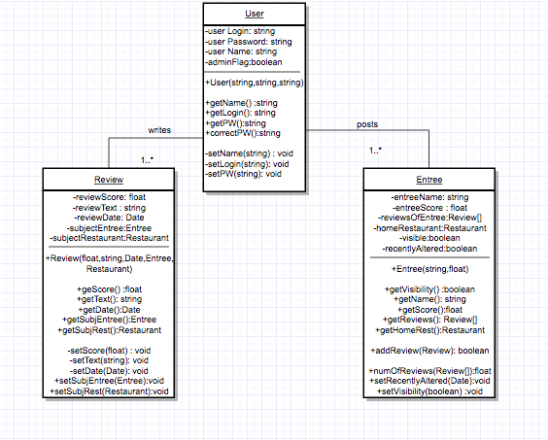

Since these three classes are so interdependent on one another, we chose to define all three. All of these classes have constructors that utilize the setters in each class to make those objects.

The correctPW(string) function within User will be used by the database for login confirmation.

Review uses the Date data type within java, which simply stores a formatted number containing the time at which it was allocated.

The setVisibility(boolean) functions within the Entree class actually receive the user’s adminFlag boolean value, so that only admins can change an item’s visibility. Entree

**2) Sequence Diagram**

<https://go.gliffy.com/go/share/s4lu47pk1bu8uw56w6kp>

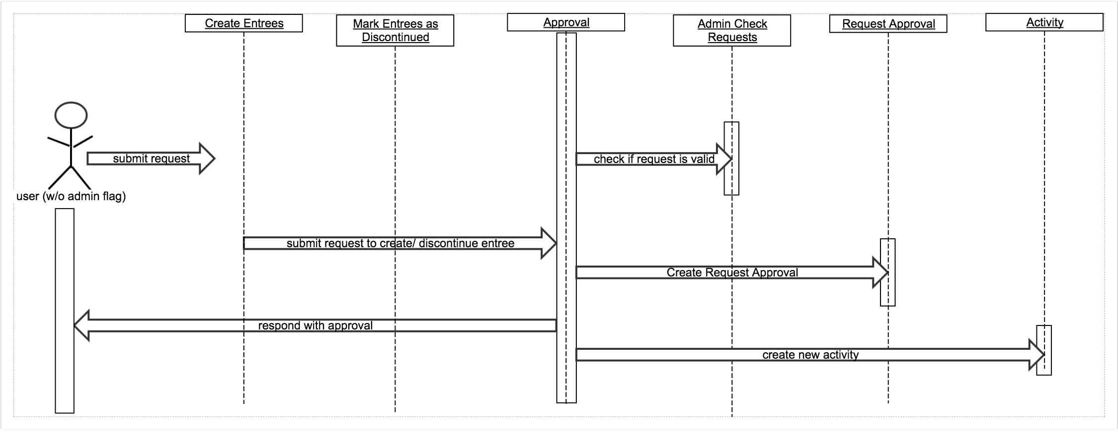

Functional requirements:

-With admin approval, user should be able to create entree entries for use by other users, mark entrees as discontinued, or mark them as having their recipes recently altered

3) ERD and Relational Diagrams

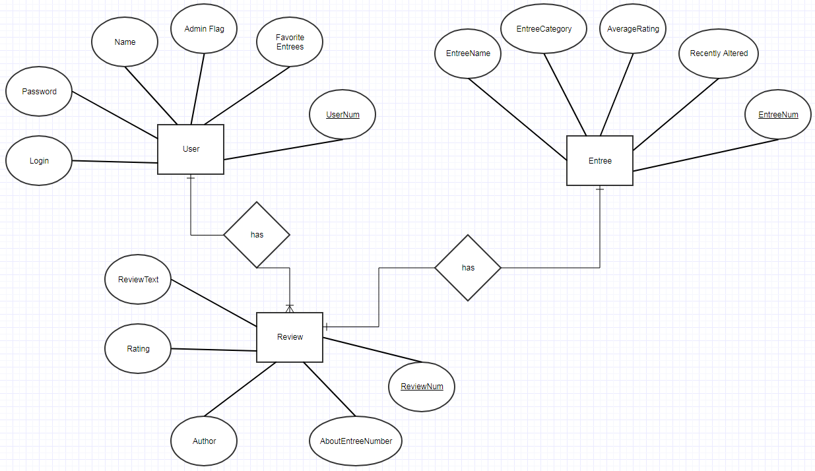

**ERD**

Functional Requirements:

* Each user using the app shall have their own login/ user ID
* The system should generate a list of entrees at a specific restaurant.
* User should be able to choose how entries are searched for based on multiple criteria, including average review score, genre of restaurant

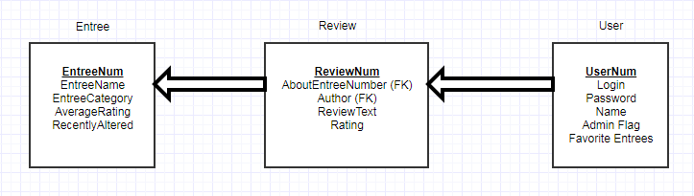

**Relational Diagram**

Functional Requirement: A user shall be able to post reviews of entrees